f ENGL 370: The Melodrama: Moving tales and Moving Pictures f
TR 10:50-12:05
Dr. Tim Carens & Dr. John Bruns
The proposed course will trace the emergence of the melodrama in early 19th-century Anglo-American culture and follow the development of its influence on other literary genres, principally the Victorian novel and 20th-century and contemporary films. Through analysis of tear-jerking tribulations, heart-stopping revelations, and last-minute rescues, its innocent heroines and dastardly villains, and other forms of excess that characterize its narratives, the course will use the melodrama as a way to consider past and present attitudes toward sexuality, the class system, the institution of marriage, racial identity, and other topics. The course will begin with the study of popular melodramas such as Isaac Pocock’s “The Miller and his Men” (1813) and Samuel Arnold’s “The Woodsman's Hut” (1814). After considering the plots, character types, and themes of such typical works, the class will jump from stage to page, considering melodramatic novels such as Elizabeth Gaskell's Mary Barton (1848) and Bram Stoker's Dracula (1897). The emergence of silver-screen melodramas such as D.W. Griffith's Broken Blossoms (1919) and Clarence Brown's Flesh and the Devil (1926), will round out the first half of the course. In the second half, a series of thematic units will enrich understanding of melodramatic forms of art by pairing 19th-century novels with 20th- and 21st-century films, such as Oliver Twist and Slumdog Millionaire. We will end the course by examining several films independently, such as All That Heaven Allows, Silence of the Lambs, Magnolia, and Far from Heaven.
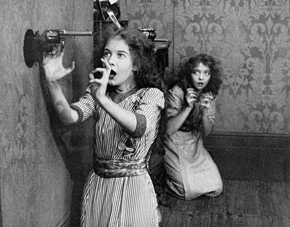
Dorothy and Lillian Gish in Unseen Enemy (dir. D.W. Griffith, 1912)

d English 370 satisfies the Theme, Genre, or Author-Centered Requirement d

